FOR IMMEDIATE RELEASE Contact: Alexandra Nelson
June 19, 2018 Communications Director
212-254-4710 ext 19
alexandra@swanngalleries.com

Lewis Evans Reaches $125K in Maps & Atlases at Swann

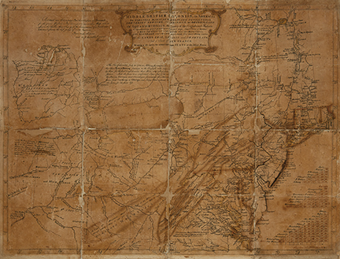

MAPS & ATLASES, NATURAL HISTORY & COLOR PLATE BOOKS

Sale 2512; June 6, 2019

Sale total: $872,342
Estimates for the sale as a whole: $548,150-$828,375
We offered 400 lots; 334 sold (84% sell-through rate by lot)
All prices include Buyer’s Premium.

New York– “There was strong bidding across the board and it’s hard not to be pleased with the general outcome of the sale,” said Maps & Atlases Specialist, Caleb Kiffer of Swann Galleries June 6 sale of Maps & Atlases, Natural Science & Color Plate Books which saw an 84% sell-through rate. Highlights included rare cartographic publications by Lewis Evans and Petrus Plancius, as well as color plate books by John Fisk Allen and Willian Sharp.
The star of the auction was the May 2, 1755 draft of A General Map of the Middle British Colonies in America by Lewis Evans. The early proof of the historic map that which documented the Colonies into Ohio for the first time sold for $125,000. “Having the opportunity to bring the Lewis Evans 1755 pre-production proof copy to auction has been a highlight of my many years in this business. It jump-started my heart the moment the consignor presented it to me and continued beating at a fast pace up until the moment it hammered. I'm calling the map an artifact, which it truly is, and having it double the estimate demonstrates its historical significance. I'm very pleased with the outcome and honored to have brought it out into the public realm here at Swann Galleries,” Kiffer said of the offering.
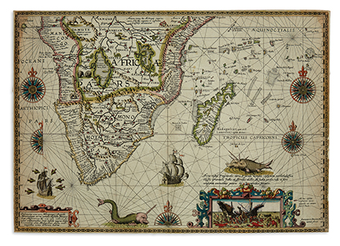
A 1792 Plan of the Town of Baltimore and its Environs by Antoinne Pierre Folie ($21,250) and John Montresor’s large 1775 map of the Hudson River Valley ($8,125) concluded an overall spectacular offering of American cartography.
Decorative cartography of note included Petrus Plancius’ 1592-94 map of Southern Africa, which featured fanciful beasts, sea monsters and a scene of giant lobsters devouring a ship ($87,500). Two works by Pieter Verbiest found success: a double-hemispheric world map from 1636 reached $25,000, as well as a 1639 representation of Spain and Portugal sold for $8,450.
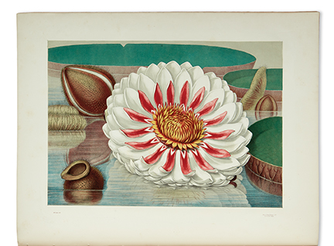
John Fisk Allen and William Sharp’s Victoria Regia, 1854, which consisted of six chromolithographed plates of the life phases of the Great Water Lily of America, lead the selection of natural history and color plate books at $30,000. Further highlights featured George Catlin’s North American Indian Portfolio, 1844, 25 tinted lithographed plates depicting Catlin’s travels of the Great Plains in the 1830s ($27,500), and a complete run of William Curtis’ The Botanical Magazine, 1787-1827 ($7,800).
Additional material of note included John Carte’s Frontispiece of the Cosmographical Clock, the only known example representing the events of December 3, 1699, which was won for $15,000.
Swann Galleries is currently accepting consignments for the fall 2019 season. Visit swanngalleries.com or download the Swann Galleries App for catalogues, bidding and inquiries.

Top lots Prices with buyer’s premium

63 Lewis Evans, A General Map of the Middle British Colonies, in America, proof copy, annotated, $125,000 D
signed & dated by Evans, Philadelphia, 1755.
179 Petrus Plancius, Delineatio, Orarum Manicongi, Angolae, Monomotapae, Terrae Natalis, Zofalae, $87,500 D
Mozambicae, Abyssinorum, Amsterdam, 1592-94.
268 Jacob Robyn, The First Part of the Burning Fen, Discovering the Whole West-Indies, Amsterdam, $30,000 D
circa 1680.
277 John Fisk Allen & William Sharp, Victoria Regia, Boston, 1854. $30,000 D
290 George Catlin, North American Indian Portfolio, London, 1844. $27,500 D
215 Pieter Verbiest, Nova Totius Terrarum Orbis Geographica, Antwerp, 1636. $25,000 C
69 Antoinne Pierre Folie, Plan of the Town of Baltimore and its Environs, Philadelphia, 1792. $21,250 D
35 John Carte, The Frontispiece of the Cosmographical Clock, hand-colored broadside, London, $15,000 C
circa 1699.
41 Henri Chatelain, Carte Tres Curieuse de la Mer du Sud, Amsterdam, 1719. $11,875 C
83 Vincenzo Maria Coronelli & Jean Baptiste Nolin, Partie Occidentale du Canada ou de la $11,875 D
Nouvelle France, Paris, 1688.
275 Nicolas Visscher, Atlas Minor Sive Geographia Compendiosa, Amsterdam, circa 1700. $10,625 D
214 Pieter Verbiest, Nova Carte Del Muy Podroso Reyno d’Espania, Antwerp, 1639. $8,450 C
142 John Montresor, A Map of the Province of New York, with Part of Pensilvania, and New England, $8,125 C
London, 1775.
156 Kummer & Dopler Heine, New-York, large hand-colored aquatint, 1851. $8,125 C
265 John Ogilby, America: Being the Latest and Most Accurate Description of the New World, $8,125 D
London, 1671.
381 Thomas Moran, The Great Salt Lake of Utah, chromolithograph, 1875. $8,125 C
296 William Curtis, The Botanical Magazine, complete run of 54 volumes, London, 1787-1827. $7,800 C
168 Abraham Ortelius, Islandia, Antwerp, 1598. $7,250 C
272 Thomas, Cowperthwait & Co. & Samuel Augustus Mitchell, A New Universal Atlas Containing $7,250 C
Maps of the Various Empires, Kingdoms, States and Republics of the World, Philadelphia, 1851.

Key: C = Collector; D = Dealer

Additional highlights can be found here.
Captions:
Lot 63: Lewis Evans, A General Map of the Middle British Colonies, in America, proof copy, annotated, signed & dated by Evans, Philadelphia, 1755. Sold for $125,000.
Lot 179: Petrus Plancius, Delineatio, Orarum Manicongi, Angolae, Monomotapae, Terrae Natalis, Zofalae, Mozambicae, Abyssinorum, Amsterdam, 1592-94. Sold for $87,500.
Lot 277: John Fisk Allen & William Sharp, Victoria Regia, Boston, 1854. Sold for $30,000.

Specialist: Caleb Kiffer • caleb@swanngalleries.com • 212-254-4710 x 17
Press: Alexandra Nelson • alexandra@swanngalleries.com • 212-254-4710 x 19
Social media: @swanngalleries
# # #
ILLUSTRATED CATALOGUE, ADDL. IMAGES & COMPLETE PRICES REALIZED ON REQUEST

Swann Auction Galleries is a third-generation family business as well as the world’s largest auction house for works on paper. In the last 75 years, Swann has repeatedly revolutionized the trade with such innovations as the first U.S. auction dedicated to photographs and the world’s only department of African-American Fine Art. More than 30 auctions and previews are held annually in Swann Galleries’ two-floor exhibition space in Midtown Manhattan, and online worldwide. Visit swanngalleries.com for more information.

